
East West University
Department of Computer Science and Engineering

Course: CSE251 Electronic Circuits
Expt No.: 4
Title: Adder and Amplifier Circuits Using 741 Op Amp

Objectives:
- To familiarize with the 741 Op Amp Integrated Circuit (IC).
- To design and construct an adder using 741 Op Amp.
- To design and construct an amplifier using 741 Op Amp.

Introduction:
Operational Amplifier (Op Amp) is a differential amplifier and can perform mathematical operations such as addition, subtraction, etc. This is an integrated circuit (IC).

The block diagram of the 741 Op Amp is shown in Figure 1. It has 8 pins. To identify the pins of the 741 Op Amp in the laboratory, place the Op-Amp on the trainer board in such a way that the notch is in your left side. Then the pin number should be identified as shown in Figure 1.

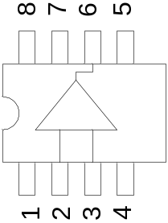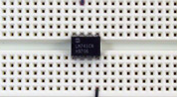
Figure 1. Block diagram of the 741 Op-Amp

The names of different pins are as follows:
1: Offset null (usually not used)
2: Inverting input terminal
3: Non-inverting input terminal
4: Negative DC power supply (usually 5-15V negative)
5: Offset null (usually not used)
6: Output terminal
7: Positive DC power supply (usually 5-15V positive)
8: Not connected (NC)

The Op Amp acts as an adder when the non-inverting input terminal is grounded and two or more signals are fed to the inverting input via resistors of appropriate values. The output becomes negative of the sum of the input signals.

A non inverting amplifier produces the amplified output equal to the input multiplied by the closed loop gain, which is determined by the appropriate resistances.

Circuit Diagram:
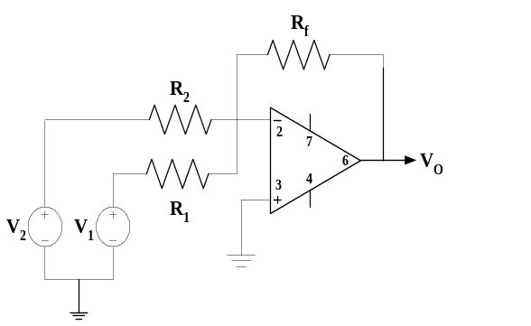
Figure 2. An adder circuit using 741 Op Amp.

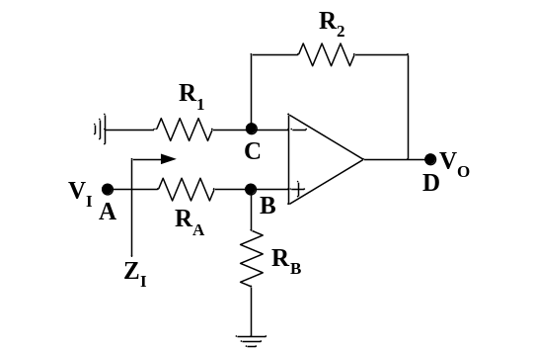
Figure 3. A non inverting amplifier circuit using 741 Op Amp.

Equipments and Components Needed:
- Digital trainer board
- DC power supply
- Signal generator
- Oscilloscope
- Digital multimeter
- 741 Op Amp (1 pc)
- Resistor (as required from pre-lab design)
- Breadboard
- Connecting wires

Pre-Lab Report Question:
- DESIGN OF ADDER CIRCUIT: Design the adder circuit shown in Figure 2 (determine the values of the resistors) so that it implements the function 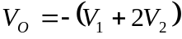. The available set of resistances that you can use is 100Ω, 1KΩ, 2.2KΩ, 3.3KΩ, 5.6KΩ, and 10KΩ. For design safety, take R_{f} as high as possible. In your design, if exact value of resistance is not available, choose the nearest one.
- DESIGN OF AMPLIFIER CIRCUIT: Design the non inverting amplifier circuit as shown in Figure 3 (determine the values of the resistors) so that the closed loop gain is 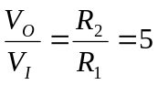. The available set of resistance that you can use is 100Ω, 1KΩ, 2.2KΩ, 3.3KΩ, 5.6KΩ, and 10KΩ. For design safety, take R₂ as high as possible. For proper operation of the amplifier circuit, assume that R_{A} = R₁ and R_{B} = R₂. In your design, if exact value of resistance is not available, choose the nearest one. With your design, set V_{I} = 1V and calculate the voltages at nodes A, B, C, and D. Also, calculate the currents through the resistances R₁, R₂, R_{A}, and R_{B} and the input impedance 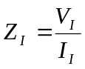.
Lab Procedure:
ADDER CIRCUIT:
- Collect the resistances of your design from the lab assistant and measure them and write them down.
- Connect the circuit as shown in Figure 2 with the resistance values from your prelab design. Use a +15V DC power supply to terminal 7 and -15V DC power supply to terminal 4 of the Op Amp from the digital trainer board.
- Use 5V from digital trainer board as V₁ and 2V from DC power supply as V₂. Measure the output using multimeter and write it down.
- Replace the V₁ by a 5V peak to peak 1 KHZ sine wave from the signal generator and observe the output in channel-2 in DC mode. Invert channel-2 and write the amplitude.

AMPLIFIER CIRCUIT:
- Collect the resistances of your design from the lab assistant and measure them and write them down.
- Set up the circuit as shown in Figure 3 using the resistances from your prelab design. Use a +15V DC power supply to terminal 7 and -15V DC power supply to terminal 4 of the Op Amp from the digital trainer board.
- Set V_{I} = 1V from the DC power supply.
- Measure the voltages at nodes A, B, C, and D using multimeter and write them down.
- Measure the voltages across resistances R₁, R₂, R_{A}, and R_{B} and write them down.

- Have the datasheet signed by your instructor.

Post-Lab Report Questions:
ADDER CIRCUIT:
- From the measurement in step 3, verify your design.
- Does the amplitude measured in step 4 verify your design? Explain.
- Simulate the circuit shown in Figure 2 in Pspice. Use V₁ a 5V peak to peak, 1KHZ, 0⁰ phase sine wave and V₂ a 5V peak to peak, 1KHZ, 90⁰ phase sine wave. Perform simulation for 4 cycles (transient analysis for 4 ms) and attach the printed output with your report.
- Write the expressions of V₁ and V₂ of Question 3 in phasor domain, add them, and write the result in time domain as a sine function. Compare it with the Pspice output in terms of amplitude, phase angle, and time period.

AMPLIFIER CIRCUIT:
- Compare the measured voltages at nodes A, B, C, and D in step 8 with your prelab results.
- From your measured voltages at nodes B and C in step 8, comment on the virtual ground of Op Amp.
- From your measured voltages at nodes A and D in step 8, calculate the gain and verify with prelab result.
- From the measured voltages across the resistances in step 9, calculate the currents through them and compare them with your prelab results.
- From your measured voltages at node A in step 8 and across R_{A} in step 9, calculate Z_{I} and compare it with your prelab result

